**User Interface**

The user interface of our web application is developed to be highly adaptive to multiple platforms. Allowing diverse demographics to access the website and utilize the functionalities the website provides. The target audience for the application are visitors and judges at the Capstone Design Expo. Through this a safe assumption of high traffic on mobile is made, influencing the UI to have multiple mobile specific functions. This section comprehensively walks you through the design decision which are made throughout our development cycle.

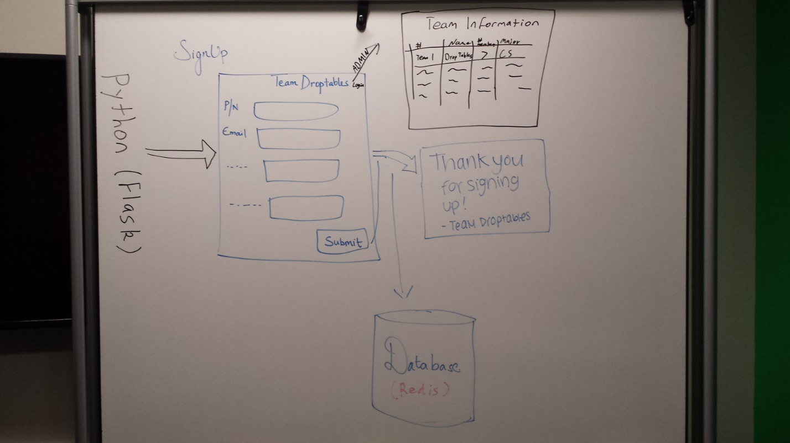

* This was a rough sketch regarding the Entry forms for teams. A screen with inputs which are tailored to the needs of the clients and further a Thank You screen which appears as the user satisfies the requirements.

Registration system.

The registration screen is very straight forward. The screen allows the users (Students) to register with all the required inputs available and labeled clearly. Also with the registration system, it allows administrators to view the teams which are registered real-time in a table format.

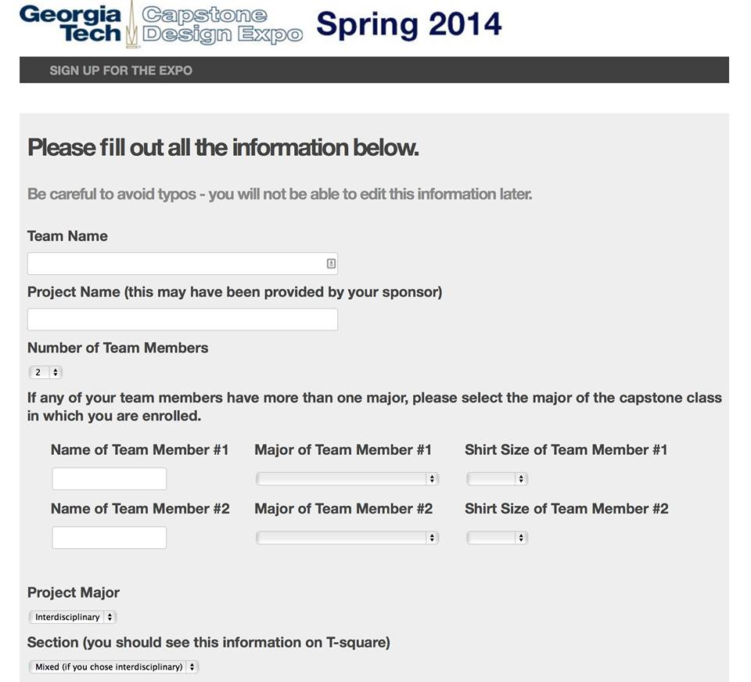Registration SignUp Form

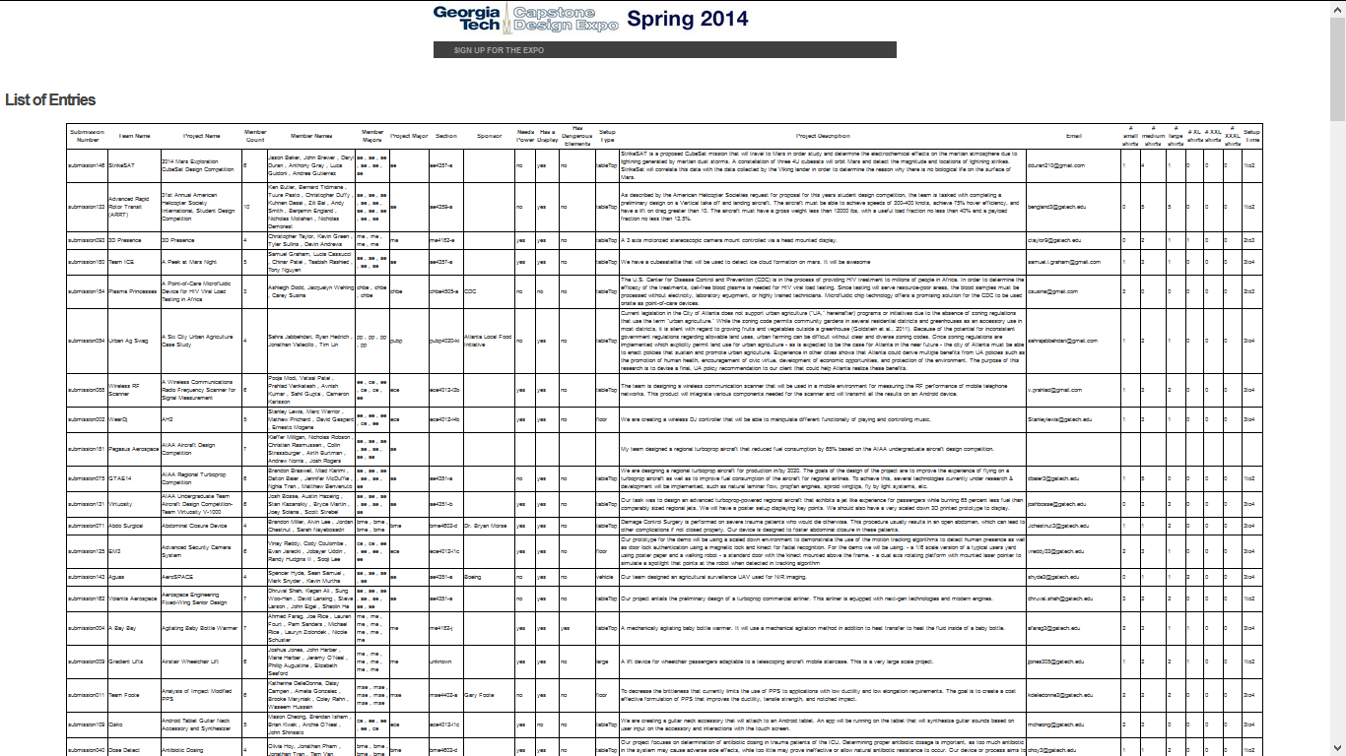Administrative table with all the teams which have signed up.

Website (Web Application)

The web application, main part of our project is influenced by metro layout of Microsoft Design. The design of the application is done to improve the efficiency of the user, therefore providing them with simple options in button layout. Overall it utilizes Gestalt principles of design to make sure the user has a swifter experience with the application and solve their purpose as quickly as possible. Also the colors which are used are analogous to Georgia Tech as we have used Navy and Gold. Similarly the icons and buttons are using the same colors with Helvetica font to follow the requirements set by Georgia Tech communications.

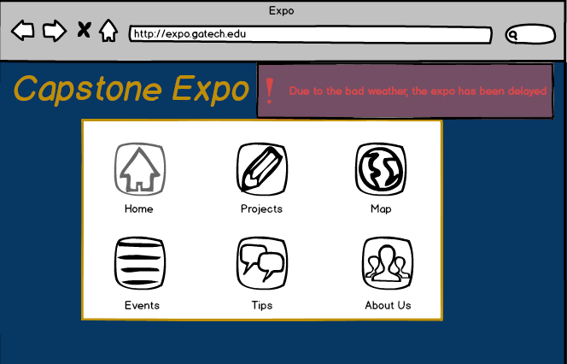

MockUp of the application.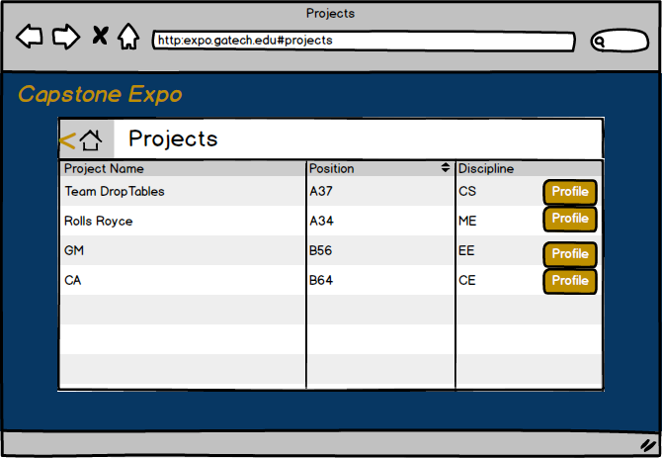

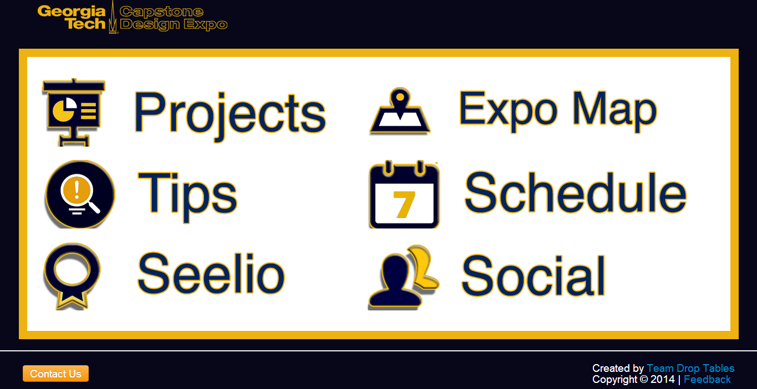

Application at the end of developer-life cycle. As observed, the color usage was very conservative, Navy Blue and Gold. Additions which were done incrementally were the search button, which uses transitions to enlarge making sure it is mobile adaptive.

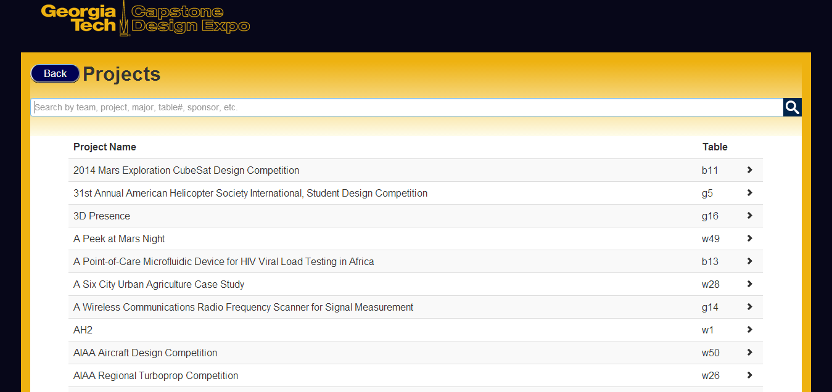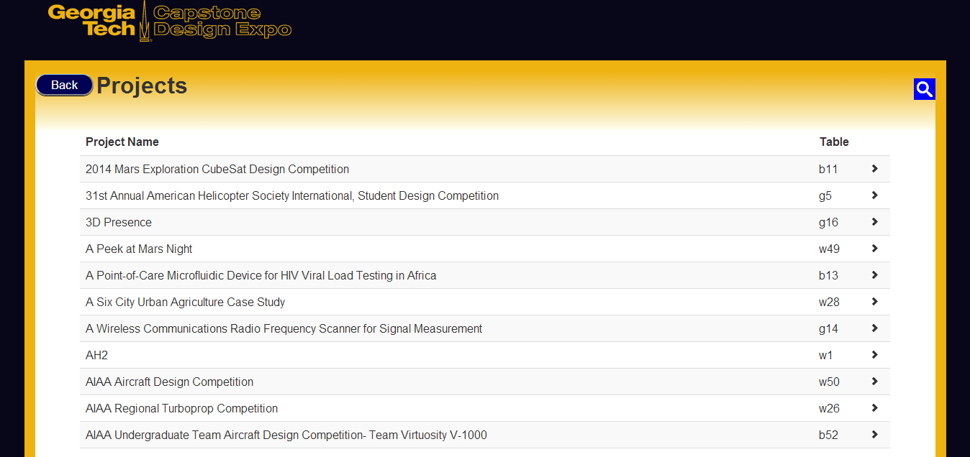

Map Design

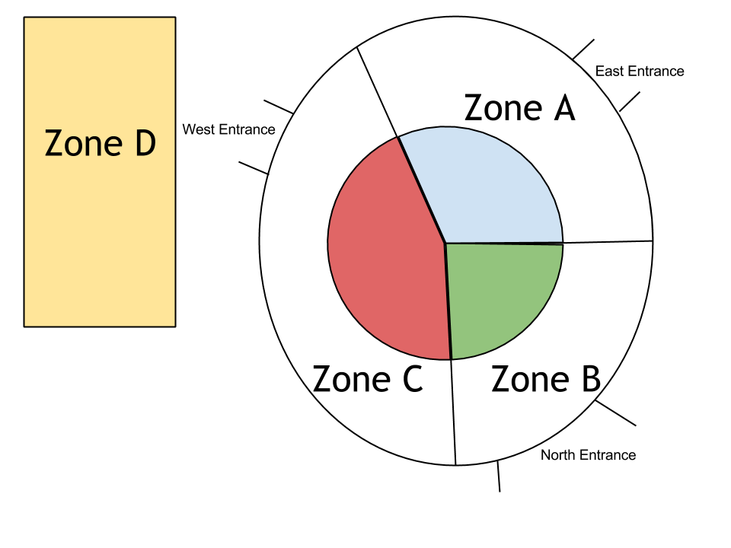

Our Map design is inspired by the functionalities supported by D3 javascript library. The color codes are encoded with the support of the clients. Further the Details on Demand is provided so that the user will have a better understanding about the location they have chosen. The map is highly interactive and uses UML schema explained in detail on the Design documentation.

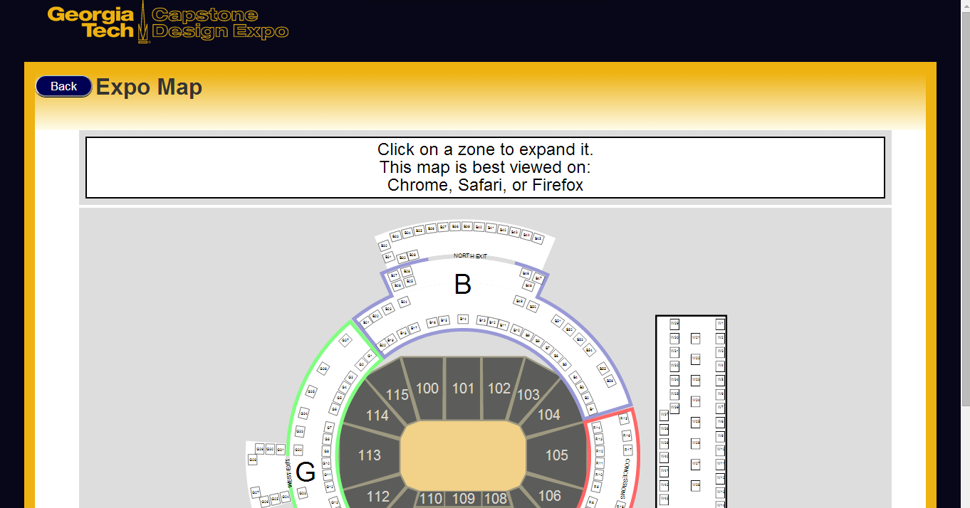

Mobile Screens

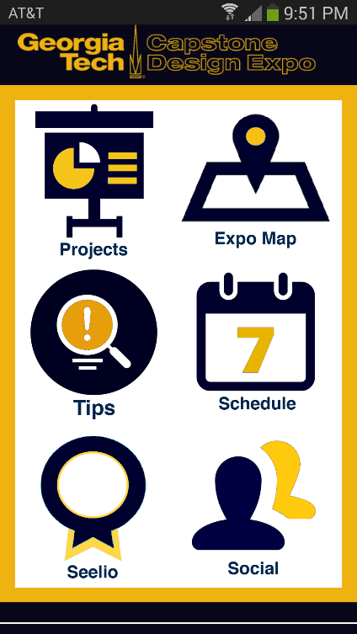 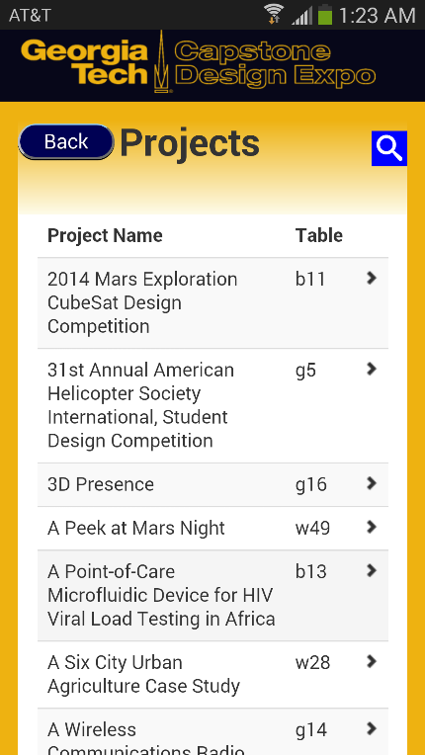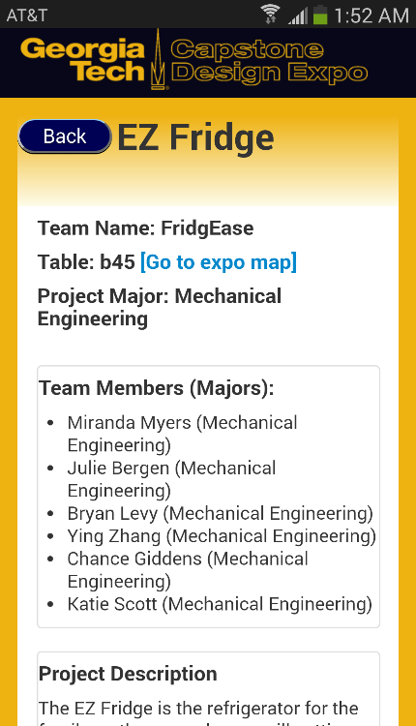 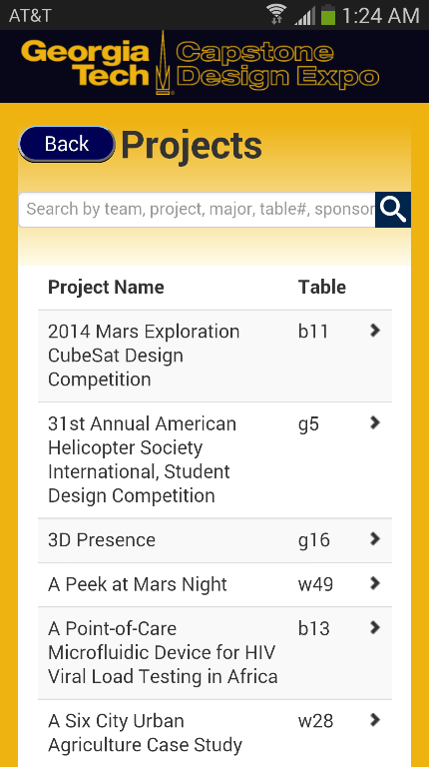

The mobile screens are embedded with new icons which are set to focus on the icons. The emphasis is on the icons which allows the user to make their decision quicker. Overall in our application, we wanted to reduce the redundancy and improve the time spent on the menu screens.

